**Exercise No:1**

**Date:14-10-2020**

**Aim:**

**To print the calendar of a given month and year using python.**

**Program:**

**import calendar**

**y = int(input())**

**m = int(input())**

**if (m > 0 and m <= 12) and (y>=1000 and y<=9999):**

**print (calendar. Month (y, m))**

**else:**

**print ("Invalid Input")**

**Link:**

[**http://103.53.53.18/mod/vpl/forms/edit.php?id=229&userid=1684#**](http://103.53.53.18/mod/vpl/forms/edit.php?id=229&userid=1684#)

**Output:**

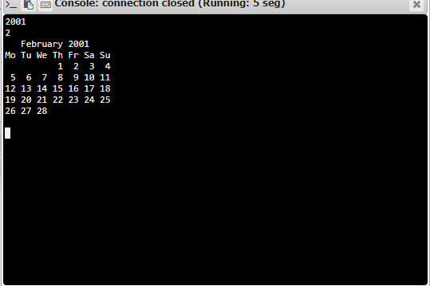

**Result:**

**Thus the calendar of the given month and year printed successfully .**